Assignment-9 EEC-3150 Engineering Programming II
- In the Blackboard Resources is a LinkedIn Learning course entitled Python Essential Training.

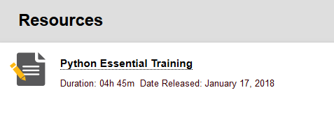
Review any lessons from the following chapters to increase your understanding:
Chapter 14 Modules

You may choose any of the videos, or all of the videos that will increase your knowledge of the Python programming language. You are to enumerate three learnings from the videos you have selected. Each of the three learnings should be described in one or two sentences.

- In the Appendix of this document is a Python implementation of the rational number data type (ADT) "Class Rational(object)". The ADT exists because of the inherent challenges with float data type, which is manifested by the fact that decimal rational numbers are not exactly represented in binary. The ADT maintains the numerator and denominator separate in distinct integers. The ADT shown in the appendix provides operator overload methods for +, <, >=, and ==. You are to add methods for -, *, /, %, <=, >, and !=. Complete the build out of the ADT by providing methods for all the following operators:

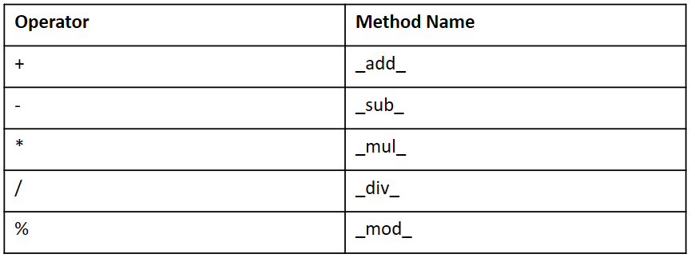
__truediv__

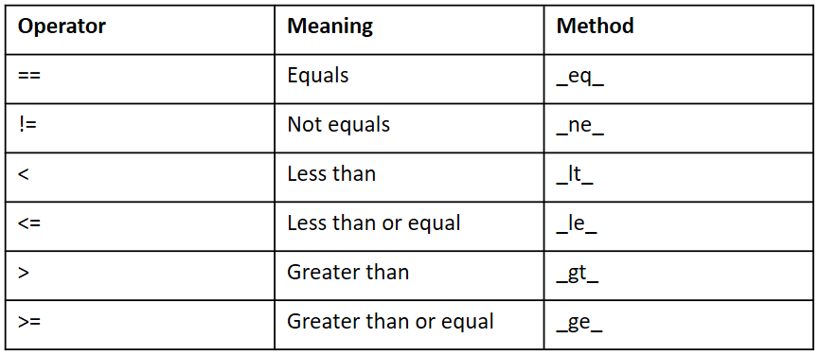

Below are the rules of rational number arithmetic:
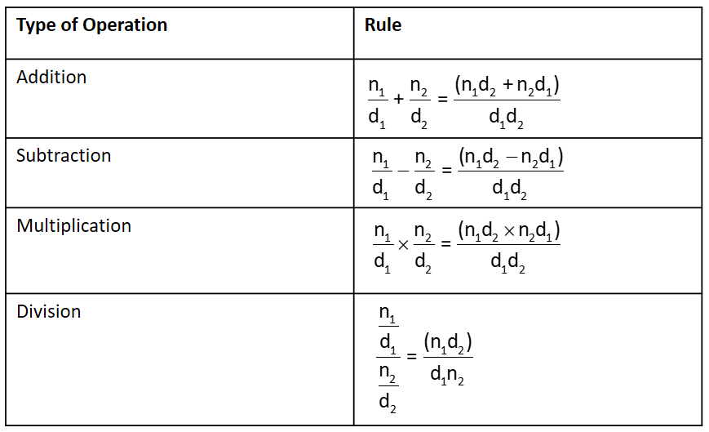
ERROR - SEE BELOW
WARNING: The rule for multiplication is in error: it is simply n₁n₂ / d₁d₂.
- Create a testing plan and build the main() that tests all methods from #2 above at least once.

Summary: #2 and #3 above are a single exercise. However, the ADT must be in a module. The main() should implement your testing plan. Be sure that in your submitted work there is a clear distinction between the ADT module (Rational.py) and the Main.py. Provide documentation.
Submit: A file called Assignment-9-Results.docx to Blackboard.

Appendix
"""
File: rational.py
Resources to manipulate rational numbers.
"""

class Rational(object):
"""Represents a rational number."""

def __init__(self, numer, denom):
"""Constructor creates a number with the given numerator
and denominator and reduces it to lowest terms."""
self.numer = numer
self.denom = denom
self._reduce()

def numerator(self):
"""Returns the numerator."""
return self.numer

def denominator(self):
"""Returns the denominator."""
return self.denom

def __str__(self):
"""Returns the string representation of the number."""
return str(self.numer) + "/" + str(self.denom)

def _reduce(self):
"""Helper to reduce the number to lowest terms."""
divisor = self._gcd(abs(self.numer), self.denom)
self.numer = self.numer // divisor
self.denom = self.denom // divisor

def _gcd(self, a, b):
"""Euclid's algorithm for greatest common divisor."""
(a, b) = (max(a, b), min(a, b))
while b > 0:
(a, b) = (b, a % b)
return a

# Methods for arithmetic and comparison operators
def __add__(self, other):
"""Returns the sum of the numbers."""
newNumer = self.numer * other.denom + \
other.numer * self.denom
newDenom = self.denom * other.denom
return Rational(newNumer, newDenom)

def __lt__(self, other):
"""Returns self < other."""
extremes = self.numer * other.denom
means = other.numer * self.denom
return extremes < means

def __ge__(self, other):
"""Returns self < other."""
extremes = self.numer * other.denom
means = other.numer * self.denom
return extremes >= means

def __eq__(self, other):
"""Tests self and other for equality."""
if self is other:
return True
elif type(self) != type(other):
return False
else:
return self.numer == other.numer and \
self.denom == other.denom

def main():
oneTenth = Rational(1,10)
print(oneTenth)

if __name__ == '__main__': main()

